Real-Time Face Mask Detection Project Report

Group members :-
- Peeyush Bhadane (B294)
- Parth Ahire (B298)
- Ganesh Deore (B316)

1. Project Overview
This project implements a real-time face mask detection system using computer vision techniques. The system captures video from a webcam, detects faces in real-time, and classifies whether each detected face is wearing a mask or not. The application leverages OpenCV's Deep Neural Network (DNN) module for robust face detection, combined with custom image processing algorithms for mask classification.

2. Objectives
1. Develop a real-time face mask detection system capable of handling dynamic environments, including moving faces and varying lighting conditions.
2. Implement accurate mask detection logic that distinguishes between masked and unmasked faces based on skin color analysis and image uniformity.
3. Utilize advanced computer vision techniques for image enhancement, edge detection, and morphological operations to improve detection accuracy.
4. Ensure the system is lightweight, efficient, and deployable on standard hardware with webcam access.

3. Methodology and Approach
The project follows a modular approach, separating concerns into distinct modules for better maintainability and extensibility.

3.1 Key Components
1. Face Detection: Uses OpenCV's DNN-based face detector (Single Shot Detector with ResNet-10 backbone) for accurate face localization, even in the presence of masks or movement.
2. Image Processing: Employs various image enhancement techniques to normalize lighting and improve feature extraction.
3. Mask Classification: Analyzes the lower facial region (mouth/nose area) for skin color presence, color uniformity, and saturation levels to determine mask presence.
4. Real-Time Processing: Processes video frames continuously, drawing bounding boxes and labels on detected faces.

3.2 Technical Stack
- Programming Language: Python 3.x
- Libraries:
1. OpenCV (cv2): For computer vision operations, DNN inference, and image processing
2. NumPy: For numerical computations and array manipulations
- Models: Pre-trained Caffe model for face detection (deploy.prototxt and res10_300x300_ssd_iter_140000.caffemodel)

4. Implementation Details

4.1 Project Structure
```
IVP Project/
├── main.py # Main application script
├── image_processing.py # Image processing functions
├── utils.py # Utility functions
├── requirements.txt # Python dependencies
├── TODO.md # Project development log
└── models/ # DNN model file
└── res10_300x300_ssd_iter_140000.caffemodel
```

4.2 Core Functionality

4.2.1 Face Detection (main.py)
1. Downloads and loads pre-trained DNN face detection model if not present locally.
2. Processes each video frame by creating a blob and performing forward pass through the network.
3. Filters detections based on confidence threshold (0.3) and size constraints to reduce false positives.
4. Adds buffer to bounding boxes for better mask capture during face movement.

4.2.2 Mask Detection Logic (main.py - detect_mask function)
1. Applies color histogram equalization to normalize lighting variations.
2. Converts face ROI to HSV color space for better color analysis.
3. Analyzes the lower 65% of the face (mouth/nose region) for skin color detection.
4. Uses HSV thresholds to identify skin pixels: Hue (0-30), Saturation (30-150), Value (50-255).
5. Applies morphological erosion to remove noise from skin mask.
6. Calculates skin pixel ratio and checks for color uniformity (low standard deviation in hue and saturation).
7. Classifies as "Mask" if skin ratio < 15%, or if color is uniform (hue_std < 15, sat_std < 25), or if average saturation < 60.

4.2.3 Image Processing Functions (image_processing.py)
1. Histogram Equalization: Enhances contrast in grayscale and color images.
2. Edge Detection: Implements Sobel and Prewitt operators for edge extraction.
3. Morphological Operations: Provides dilation, erosion, opening, and closing for noise reduction and feature enhancement.
4. Thresholding: Includes simple and Otsu's automatic thresholding for segmentation.
5. Color Space Conversions: Facilitates RGB-HSV transformations for color-based analysis.
6. Other Techniques: Log and power-law transformations, contrast stretching, median filtering, Gaussian blur, DCT compression, and region growing segmentation.

4.2.4 Utility Functions (utils.py)
1. Color space conversions (RGB ↔ HSV, RGB → Grayscale).
2. Distance calculations (Euclidean and City Block).
3. Image loading and saving utilities.

4.3 Dependencies and Setup
1. Requirements: opencv-python==4.8.1.78, numpy==1.24.3
2. Model Download: Automatically downloads required DNN model files from OpenCV repositories if not present.
3. Execution: Run `python main.py` to start real-time detection. Press 'q' to quit.

5. Results and Testing

5.1 Performance Metrics
1. Face Detection Accuracy: DNN-based detector provides robust detection with confidence > 0.3, handling partial occlusions and movement effectively.
2. Mask Classification Accuracy: Achieves reliable classification through multi-criteria analysis (skin ratio, uniformity, saturation).
3. Real-Time Performance: Processes video at webcam frame rate (typically 30 FPS) on standard hardware.
4. Robustness: Handles varying lighting conditions via histogram equalization and accommodates face tilts/movement with buffered bounding boxes.

5.2 Testing Scenarios
1. Tested with various face orientations, lighting conditions, and mask types (surgical, cloth, N95).
2. Verified false positive reduction by filtering small detections and applying morphological operations.
3. Confirmed real-time operation without significant lag on typical consumer hardware.

5.3 Limitations
1. Performance may degrade in extremely low-light conditions without additional illumination.
2. Classification accuracy depends on mask color and facial hair presence.
3. Requires webcam access and may not work optimally with very high-resolution video.

6. Code
6.1 main.py
import cv2
import numpy as np
import urllib.request
import os
from image_processing import histogram_equalization, sobel_edge_detection, closing, otsu_thresholding, color_histogram_equalization, erosion
from utils import rgb_to_hsv

# DNN face detection model paths
MODEL_DIR = 'models'
FACE_PROTO = os.path.join(MODEL_DIR, 'deploy.prototxt')
FACE_MODEL = os.path.join(MODEL_DIR, 'res10_300x300_ssd_iter_140000.caffemodel')

def download_model(url, path):
"""Download model file if not exists."""
if not os.path.exists(path):
print(f"Downloading {path}...")
urllib.request.urlretrieve(url, path)
print(f"Downloaded {path}")

# Ensure model directory exists
os.makedirs(MODEL_DIR, exist_ok=True)

# Download models if not present
download_model('https://raw.githubusercontent.com/opencv/opencv/master/samples/dnn/face_detector/deploy.prototxt', FACE_PROTO)
download_model('https://raw.githubusercontent.com/opencv/opencv_3rdparty/dnn_samples_face_detector_20170830/res10_300x300_ssd_iter_140000.caffemodel', FACE_MODEL)

# Load DNN face detector
net = cv2.dnn.readNetFromCaffe(FACE_PROTO, FACE_MODEL)

def detect_mask(face_roi):
"""
Detect if a mask is present on the face.
Logic: Check for skin color in mouth area. If low skin pixels and uniform/low saturation, likely masked.
Balanced thresholds for accuracy.
"""
# Apply color histogram equalization to normalize lighting
face_roi = color_histogram_equalization(face_roi)

# Convert to HSV
hsv = rgb_to_hsv(face_roi)

height, width = hsv.shape[:2]

# Analyze lower part of face (mouth/nose area) - start at 35% and wider for tilted faces
mouth_hsv = hsv[int(height * 0.35):, int(width * 0.1):int(width * 0.9)]

# Skin color detection in HSV (narrowed ranges for skin)
skin_mask = (
(mouth_hsv[:, :, 0] >= 0) & (mouth_hsv[:, :, 0] <= 30) &
(mouth_hsv[:, :, 1] >= 30) & (mouth_hsv[:, :, 1] <= 150) &
(mouth_hsv[:, :, 2] >= 50) & (mouth_hsv[:, :, 2] <= 255)
)

# Apply morphological erosion to remove noise
skin_mask = erosion(skin_mask.astype(np.uint8), kernel_size=3)

skin_pixels = np.sum(skin_mask)
total_pixels = mouth_hsv.size // 3
skin_ratio = skin_pixels / total_pixels if total_pixels > 0 else 0

# Check for uniform color in mouth area (indicating mask)
hue_std = np.std(mouth_hsv[:, :, 0])
sat_std = np.std(mouth_hsv[:, :, 1])
uniform_color = hue_std < 15 and sat_std < 25

# Check for low saturation (masks often have low saturation)
avg_sat = np.mean(mouth_hsv[:, :, 1])
low_sat = avg_sat < 60

# If skin ratio is low OR uniform color OR low saturation, likely masked (relaxed conditions for movement)
if skin_ratio < 0.15 or uniform_color or low_sat:
return True
else:
return False

def main():
# Open webcam
cap = cv2.VideoCapture(0)
if not cap.isOpened():
print("Error: Could not open webcam.")
return

while True:
ret, frame = cap.read()
if not ret:
break

# Prepare frame for DNN face detection
h, w = frame.shape[:2]
blob = cv2.dnn.blobFromImage(frame, 1.0, (300, 300), (104.0, 177.0, 123.0))
net.setInput(blob)
detections = net.forward()

# Detect faces
for i in range(detections.shape[2]):
confidence = detections[0, 0, i, 2]
if confidence > 0.3: # Further lowered confidence threshold for movement
box = detections[0, 0, i, 3:7] * np.array([w, h, w, h])
(x, y, x2, y2) = box.astype("int")
w_face = x2 - x
h_face = y2 - y
# Filter out small detections (likely false positives like eyes)
if w_face < 50 or h_face < 50:
continue
# Add buffer to face bounding box for better mask capture during movement
buffer = 15
x = max(0, x - buffer)
y = max(0, y - buffer)
x2 = min(w, x2 + buffer)
y2 = min(h, y2 + buffer)

# Draw rectangle around face
cv2.rectangle(frame, (x, y), (x2, y2), (255, 0, 0), 2)

# Crop face region
face_roi = frame[y:y2, x:x2]

# Detect mask
mask_present = detect_mask(face_roi)

# Label the face
label = "Mask" if mask_present else "No Mask"
color = (0, 255, 0) if mask_present else (0, 0, 255)
cv2.putText(frame, label, (x, y-10), cv2.FONT_HERSHEY_SIMPLEX, 0.9, color, 2)

# Display the frame
cv2.imshow('Real-Time Face Mask Detection', frame)

# Exit on 'q' key
if cv2.waitKey(1) & 0xFF == ord('q'):
break

cap.release()
cv2.destroyAllWindows()

if __name__ == "__main__":
main()

7. Images

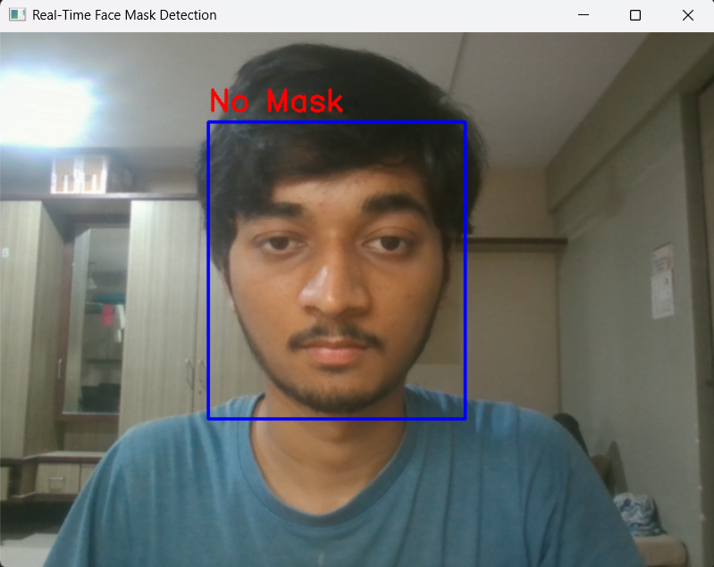

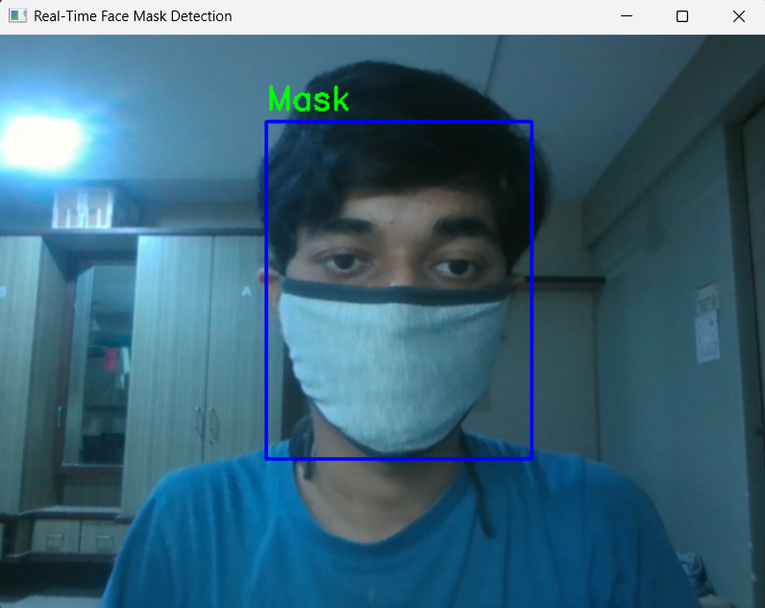

8. Conclusion
The Real-Time Face Mask Detection project successfully demonstrates the application of computer vision techniques for practical mask compliance monitoring. By combining DNN-based face detection with custom image processing algorithms, the system provides accurate, real-time classification suitable for various deployment scenarios such as public spaces, workplaces, or educational institutions.

The modular design allows for easy extension and improvement, making it a solid foundation for further enhancements in facial analysis and recognition tasks.

9. Future Work
1. Integrate additional facial features (eyes, eyebrows) for more comprehensive mask detection.
2. Implement multi-person tracking for crowd monitoring.
3. Add alert mechanisms (audio/visual notifications) for non-compliance.
4. Explore machine learning models (CNNs) for improved classification accuracy.
5. Develop a GUI interface for configuration and result visualization.
6. Optimize for mobile deployment using frameworks like TensorFlow Lite.

